https://issuu.com/aoteautanganui/docs/hawera_presbyterian_church_-_specia
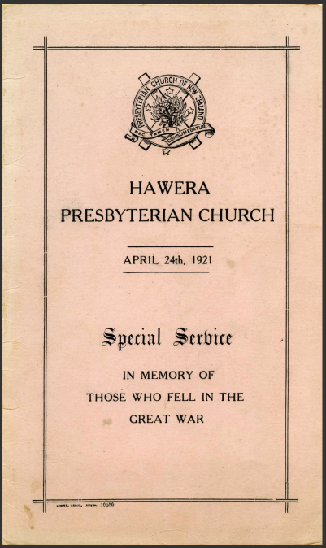
This booklet formed part of a church service and pays tribute to L. Winks, P. Campbell, A. Lethaby, A. Thomson, D. Paterson, G.E. Sargent, J. Campbell, J.L. Hogg, J. Green, T.S.D. Oldridge, H. McNiven, L.M. Taylor, A. Reid, W.D. Murray, O. Sanders, J.B. Young, T. Gerard, P.S. Livermore, and W. Smith.
