JOHN PIERCE UPTON (1913-1942)

Born 14 April 1913 at Remuera, Auckland.
Solicitor (Russell McVeagh, Auckland).

Married on 23 October 1940 at St Mark’s Church, Remuera, Auckland MARION HENDERSON FRATER, born 1921 at Auckland, daughter of James Henderson Frater (1884-1955) and Ella Sydney Florence Gill (1884-1959); died 5 October 2006 at Auckland. No children.

Died 16 February 1942 in Bangka Strait, off Sumatra, Indonesia.

Residence in New Zealand

1935: 67 Remuera Road, Remuera, Auckland (clerk)
1938, 1941: 35 Bassett Road, Remuera, Auckland (clerk)

Source: New Zealand Electoral Rolls, 1853-1981.

War Service

Royal New Zealand Naval Volunteer Reserve, HMS Fanling. Died (killed in action) in the Bankra Straits, Sumatra on 16 February 1942. Lt Upton volunteered for naval service and left for Singapore in November 1940 to serve in Coastal Defence craft, and early in 1942 a motor vessel. The motor vessel of which he was in charge was shipping evacuees at the time it was lost in Bangka Strait, Sumatra.

Source: Auckland War Memorial Museum Cenotaph Database http://muse.aucklandmuseum.com/databases/cenotaph/locations.aspx

The patrol boat HMS Fanling, commanded by Lieutenant Upton and
carrying a number of army staff officers, was intercepted by a Japanese cruiser in Bangka Strait. She opened fire with her four-pounder gun but was quickly sunk. Upton was killed in this action.

Source: Waters, Sydney David. The Royal New Zealand Navy. Wellington, Historical Publications Branch, 1956. (The Official History of New Zealand in the Second World War, 1939-1945). Chapter 29: New Zealanders in the Royal Navy, p. 474-475.

The following letter was sent to John Pierce Upton’s wife, Mrs M. H. Upton, 52 Bassett Road, Remuera, Auckland by W. J. G. Prophit, Naval Secretary, Naval Office, Wellington on 25 March 1946:

Death of Lieutenant Upton

In command of ex Customs launch “FANLING” left Singapore with a party under Brigadier Aird-Smith, comprising 6 other officers and a few British N.C.O.s and Indian other ranks (all being ex-members of Lt. Gen. Heath’s staff) who had been instructed to get away from Singapore if possible.

Left night of Feb. 15th 1942. At 6.30 a.m. on 16th found they had steamed into a Jap. Fleet of 1 cruiser, 2 destroyers and other smaller craft. Upton decided to go straight on in the hopes that his boat would not be noticed. Japs fired shot across their bows whereupon Upton stopped and brought his solitary gun, a 4-pounder, into action. “FANLING” was sunk by H. E. and incendiaries about 15 miles from land.

These facts are taken from a letter dated July 14th 1942, to Lt. Gen. Heath from Lt. Col. R. H. Long, who made Banka Island just before dawn on Feb. 18th after being nearly 48 hours in the water, swimming with a lifebelt. He is believed to be the only survivor.

The enemy made no attempt to pick up any who survived the shelling. Upton’s very gallant action in going down fighting against impossible odds deserves to be placed on record.

(sgd) Sir Shenton Thomas
Governor of Straits Settlements and
High Commissioner Malay States
4. 9. 43

Source: National Archives of New Zealand Auckland Office: BBAE series 1570 box 715 record 460/1946.

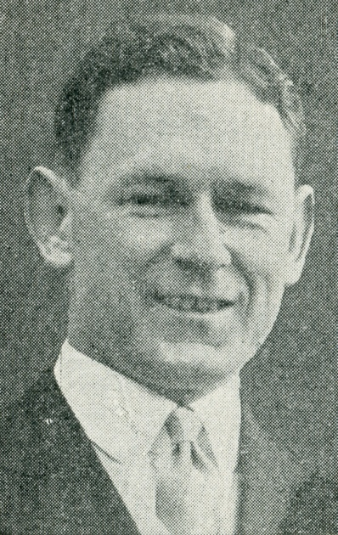

Extracted from: Millett, Tony. The Millett – Upton Connection. http://tonymillett.tripod.com/upton.html

