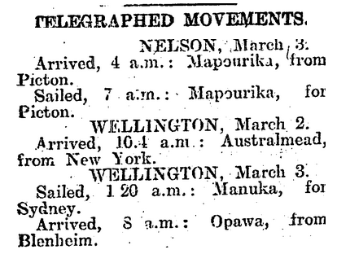

Marlborough Express, Volume LI, Issue 53, 3 March 1917, p.4

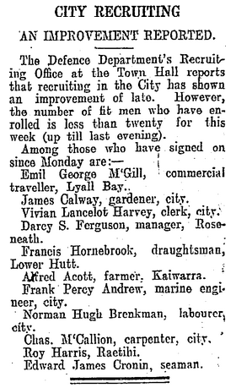

Dominion, Volume 10, Issue 3023, 9 March 1917, p.4

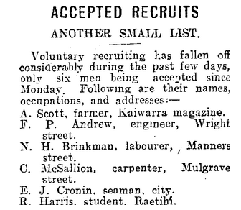

New Zealand Times, Volume XLII, Issue 9605, 10 March 1917, p.9

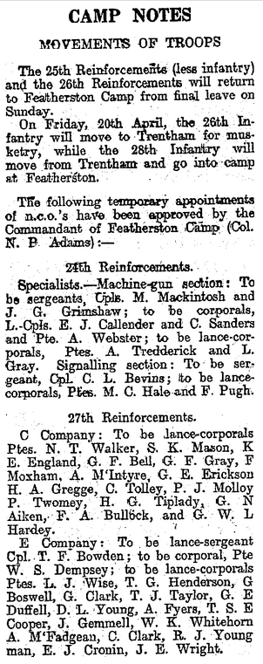

Evening Post, Volume XCIII, Issue 89, 14 April 1917, p.5

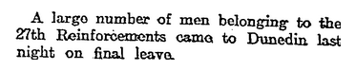

Otago Daily Times, Issue 17014, 26 May 1917, p.6

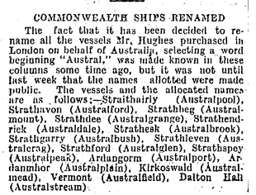

Evening Post, Volume XCII, Issue 81, 3 October 1916, p.6

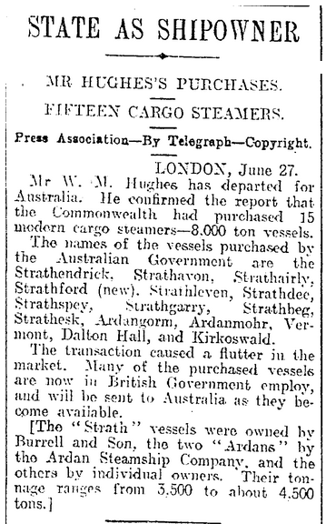

Evening Star, Issue 16152, 28 June 1916, p.6

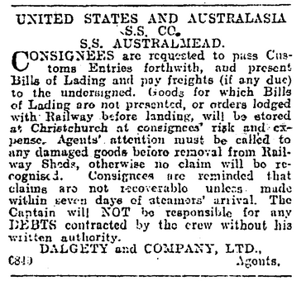

Press, Volume LIII, Issue 15843, 7 March 1917, p.1

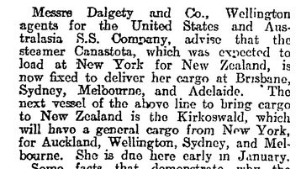

Otago Daily Times, Issue 16851, 14 November 1916, p.4

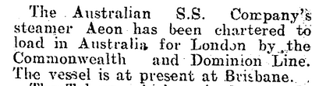

Wanganui Chronicle, Volume LXI, Issue 16629, 24 May 1916, p.4

