How a war hero ended his days drugged in a rest home
TONY WALL05:00, Dec 29 2019
- Facebook
- Twitter
- Reddit
- Email
Play Video
KATHRYN GEORGE/STUFF
Some worry that anti-psychotic drugs are being over-prescribed to keep problematic dementia patients docile.
The family of a veteran of the D-Day invasions is concerned about the medication he was given in a Hawke's Bay rest home. Tony Wall investigates.
In the mugshot taken by the Nazis, Trevor Mullinder grins as if it's his wedding day.
The guards at the Stalag Luft 1 prisoner of war camp in northern Germany had told him not to smile for the photo - so he did anyway.
"Dad was a bit of a rebel," says his daughter, Lorraine Parkinson.
READ MORE:
* Calls to stop using anti-psychotics as 'chemical restraints' for people with dementia
* Some rest homes are rejecting anti-psychotics in favour of person-centred care
Mullinder had flown Mosquito bomber raids over France in support of the D-Day invasions in June 1944.
Shot down over France five days after the initial invasion, he was captured by the Nazis and taken in an open cattle wagon to the prison camp, where he spent the rest of the war.
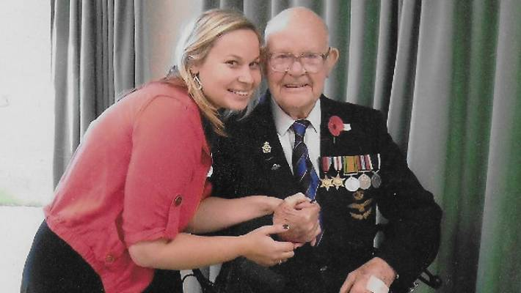
Trevor Mullinder with his granddaughter Sammie and his war medals.
On his return to New Zealand he served in the Air Force for many years before teaching maths and English at Hastings Boys' High and eventually retiring to a lifestyle block.
Around mid-2011, Mullinder was diagnosed with mid-stage dementia.
"He wasn't wandering away or anything, he was just a bit confused and he used to get a bit crotchety," says Parkinson.
His wife, Phyllis, had her own serious health problems so the family decided to put him into the Mary Doyle rest home in Havelock North.
He entered the home in March 2012 and died three months later aged 93. The home has since been purchased by the Arvida Group.
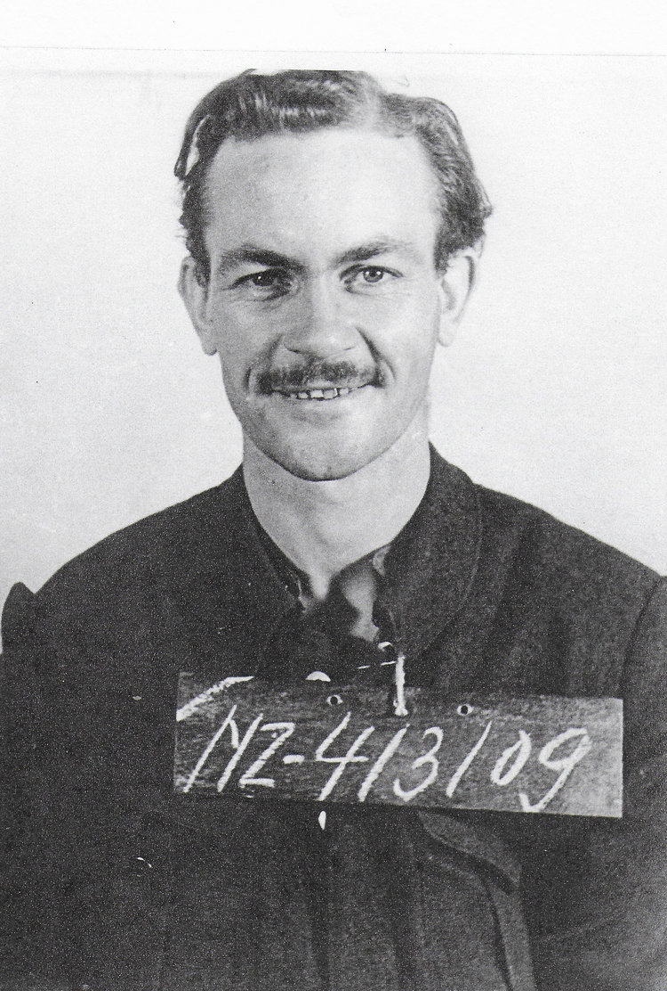
SUPPLIED/MULLINDER FAMILY
Trevor Mullinder in a German prisoner of war camp in 1944.
Parkinson and her siblings believe the medication their father was given in the home - a potentially dangerous combination of an anti-psychotic and a heart failure drug - may have hastened his demise.
She is speaking out as part of a Stuff investigation into the use of anti-psychotics in rest homes.
Several families have come forward with similar stories of elderly loved ones being routinely given the drugs - sometimes without the family's consent - when their behaviour became difficult.
"I don't want this happening to other people," Parkinson says.
Mullinder was often distressed in the nursing home and his family believe he went back to his prisoner of war days in his mind.
He would plot "escape routes" and on one occasion wouldn't let two nurses carrying a vacuum cleaner pass him in the hallway, perhaps thinking it was some kind of torture device, Parkinson believes.
"They complained about him. I was told they were very frightened."
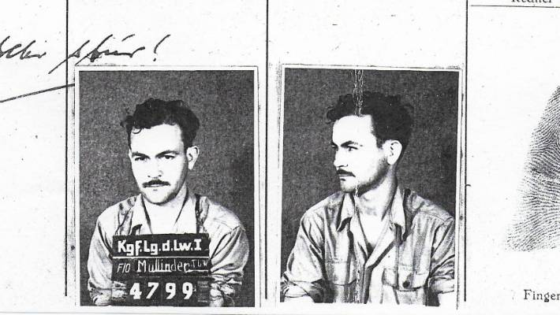
Trevor Mullinder's prisoner of war identification card.
Another time he tried to separate the men and women - Parkinson believes that related to the arrival of the Russians at his prison camp and fears they would rape Polish women working there.
"Apparently it caused mayhem... they had to put the whole ward in lockdown," Parkinson says.
Mary Doyle management, Mullinder's GP and a psycho-geriatrician decided to try him on a small dose of the new generation anti-psychotic risperidone, one of the most common anti-psychotics in rest homes.
Parkinson says she had power of attorney for her father's medical matters and welfare, but wasn't consulted.
In the US, risperidone is not approved by the Food and Drug Administration for use in dementia patients, but is often prescribed off-label.
Here and in Australia, it is the only anti-psychotic registered for behavioural and psychological symptoms of dementia.
Parkinson says it felt like staff hadn't taken enough time to get to know her father and what was bothering him.
"They just didn't have any understanding of him as a person, of his psychological trauma during the war - none of that was taken into account.
"I think that's what annoyed us the most - that he was being branded as a difficult person."
Medical charts show Mullinder was started on a very small dose - 0.5mg - which was increased to 2mg, and then 4mg.
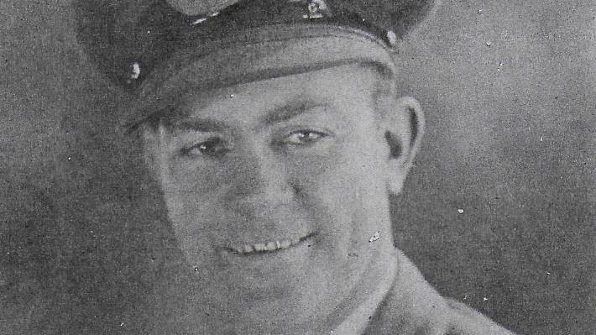
Mullinder served in the RAF during World War II.
The last increase happened in one day - the family say that was faster than recommended for their father's weight.
They were particularly concerned that Mullinder was also being prescribed 40mg of the diuretic furosemide, to treat fluid build-up around his heart.
According to Medsafe advice, caution should be used when combining the two, as studies have found the mortality rate for elderly people taking the drugs together is more than double that of risperidone alone.
Parkinson says a nurse at the home approached her with concerns about her father's medication regime.
"She took me into a private room and took a book out of a cabinet and said 'I'm really worried about your father's medication'. She said 'I don't know what you can do about it'."
Parkinson rang her father's GP, asking if a diuretic not contraindicated with risperidone could be used, but was told other drugs did not work was quickly as furosemide.
She says the GP claimed her father's psychosis was the worst case he'd seen, which she believes is "bollocks".
The GP did not respond to a request for comment.
Dr Bryan Betty, medical director of the Royal NZ College of General Practitioners, says dementia is a very difficult, complex therapeutic area complicated by the rest home environment and issues such as staffing levels.

MORE FROM
TONY WALL • NATIONAL CORRESPONDENT

