OUR SOLDIER BOYS in SOUTH AFRICA

12 March 1900 - Poverty Bay Herald
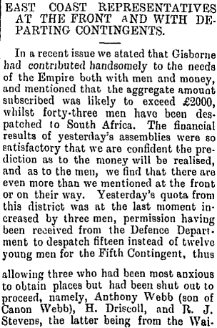
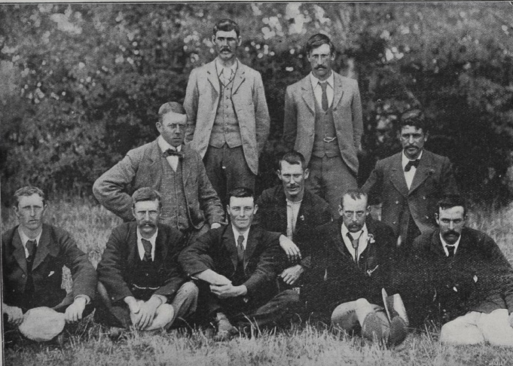
GISBORNE’S 3RD ROUGH RIDERS
William E Langford # 806; James Poynter # 813; J A B Phelps; James Gordon # 808; Rudolphus Richardson # 814; Gordon Johnstone # 810; Graham Johnstone # 809; A W Fowlds; M Pickett # 811; Audley Woods # 815.

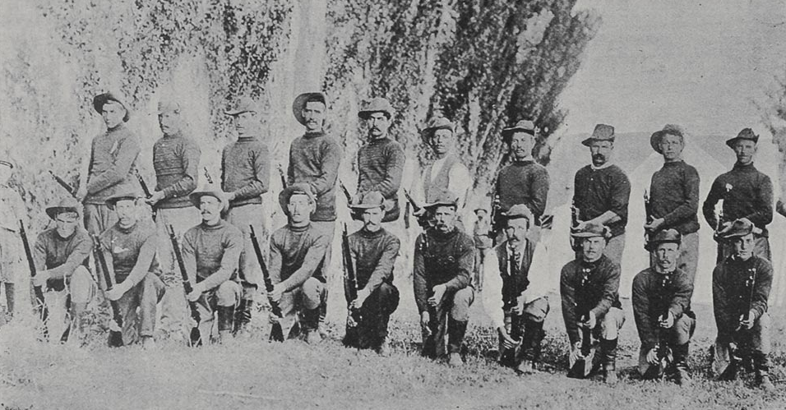
Gisborne’s 4th Contingent

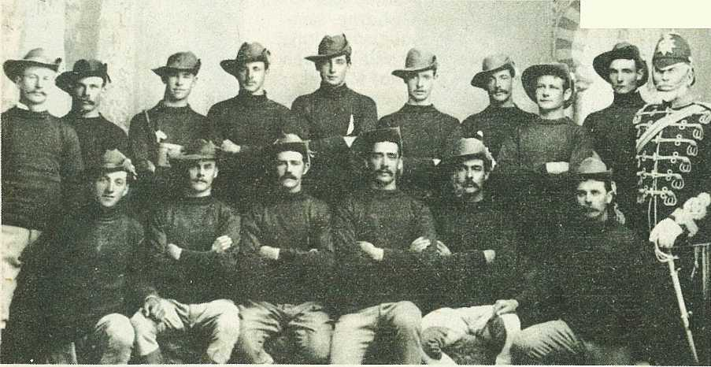
Gisborne’s 4th Contingent:
From left, in front: Arthur W Gannon # 1518; John Davidson # 1377; George Bougen # 1381, John Walker # 1375 Lt Beckham Arthur # 1383 James Langham # 1386 Cpt Winter
Back row: Fred Peakman # 1387; Francis Burch # 1379; Josiah Whitehead # 1374; Frederick Barton # 1384; David Bruce # 1385; Francis Fraser # 1376; John Rogers # 1504; Francis Sharp # 1378; Francis Bruce # 1382

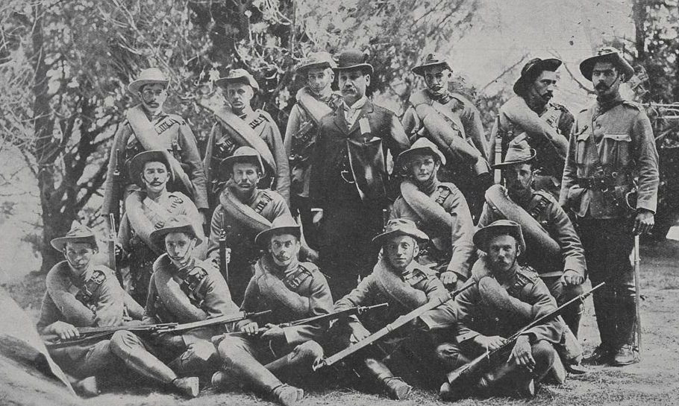
Gisborne’s 4th NZ Contingent
John Rogers # 1504, Fred Barton # 1384, David S Bruce # 1385, Francis O Bruce # 1382, John Walker # 1375, Beckham Arthur # 1383, George Bougen # 1381, Fred Peakman # 1387, Francis Sharp # 1378, James Langham # 1386, Josiah Whitehead # 1374, Robert Fraser # 1376, John Davidson #1377, Arthur Gannon # 1518, Francis Burch # 1379, with Mr James Carroll

Gisborne’s 5th Contingent:
From left, in front: Jack S Ferris # 2472, George B Carter # 2461, Frank Parker # 2508, James P Thomson # 1389, Herbert J Ferris # 1490, Major McCredie.
Back row: George A C Simpson # 2517, Herbert Yardley # 2539, Patrick Brady # 2612, William J. Brown # 2452,
Michael Ryan # 2515, George W Taylor # 2709,
John D Cameron # 2670

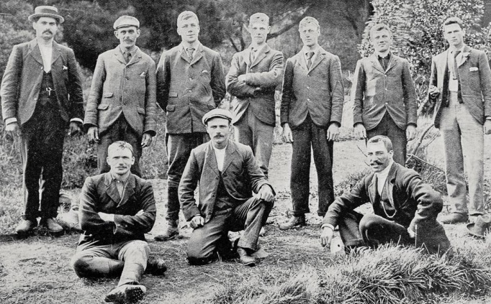
Gisborne’s members of the 7th Contingent
James Hanlon # 4176, Charles J Denny # 4156,
T F Carlyle, Norman Law # 4188, Percy W Teesdale # 4213, Edward G W Parker # 4200 , William L Cato # 4150,
Daniel D Buckley # 4143, Ernest A Guilford # 4167,
Thomas R Porter # 4124

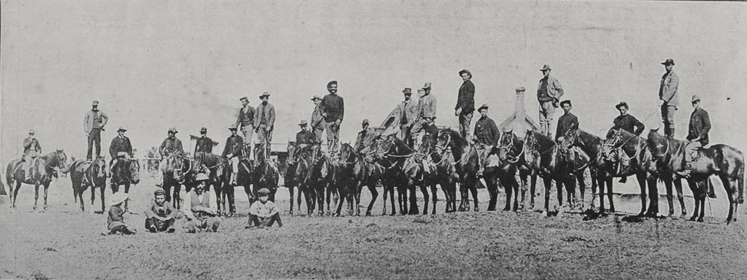
23 Mar 1900 - THE GISBORNE 4TH CONTINGENT:
A SEVERE RIDING TEST HAD TO BE PASSED BEFORE VOLUNTEERS WERE ACCEPTED FOR THE 2ND S.A. BOER WAR

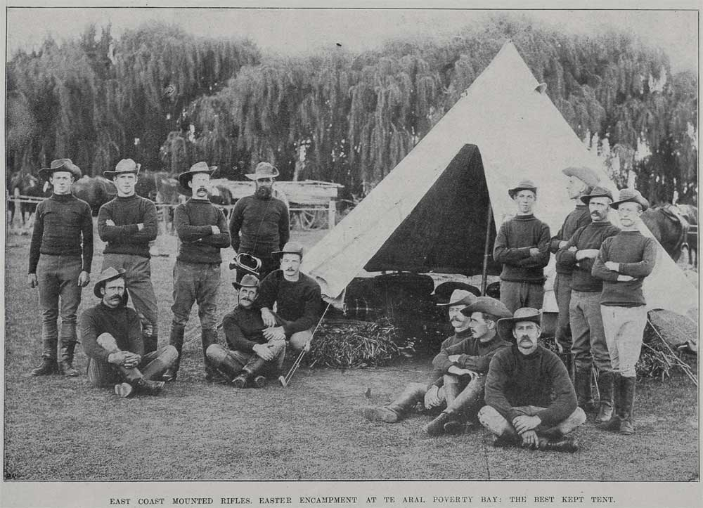
C. 1892 - East Coast Mounted Rifles Easter Camp at the showgrounds Gisborne – The Best Kept Camp.
The only figure identified is "Jim McIntosh"
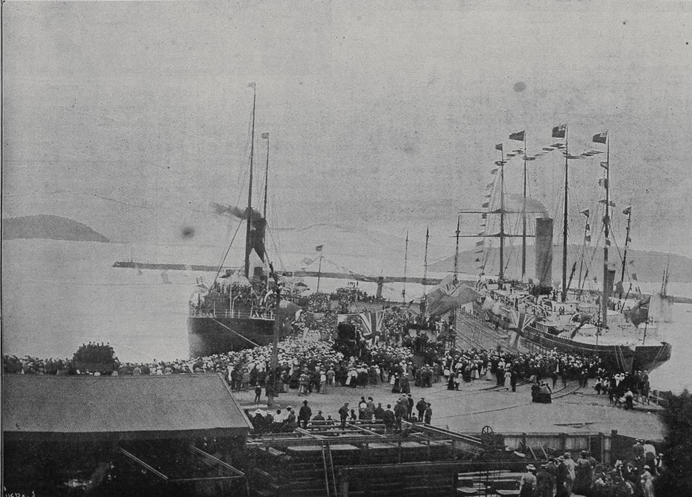
27 Feb 1900 - Scene at the departure of the ‘Knight Templae’ from Lyttleton with 3rd NZ Contingent

COOK MEMORIAL.
Poverty Bay Herald, Volume XXXII, Issue 10467, 20 September 1905, Page 3
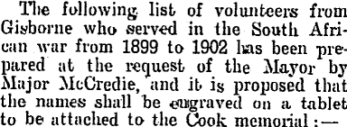
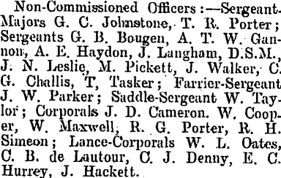

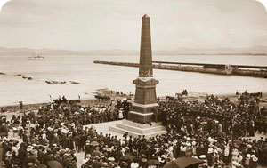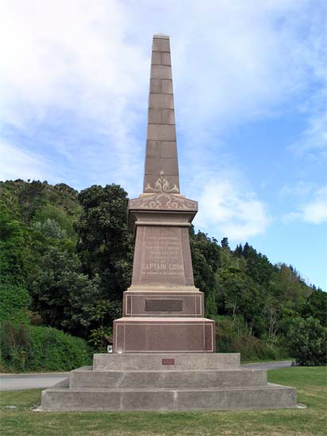
As it was in 1906  Captain Cook Memorial at Kaiti Beach with silver plague of SA Boer War Soldiers | As it is today  The Cook Memorial at its site on route to Kaiti Beach. The war veterans’ plague was removed

In September 1905 the list of volunteers from Gisborne who served in the S A Boer War from 1899 to 1902 was prepared at the request of the Mayor by Major McCredie and it was proposed that the names be engraved on a silver tablet to be attached to the Cook Memorial which was then sited at the Kaiti Beach frontage. There was national outcry of the “Memorial Folly” having the War Veterans’ names on the Captain Cook Memorial. All forgetting that money raised for the monument also was given by those who supported the Plague to Honour the S A Boer War Soldiers & Volunteers

Their names were then engraved on Marble Plaques that was affixed to the Gisborne Band Rotunda down by the banks of the Turanganui River opposite the War Memorial

May 1912

However, these marble plaques were again removed and shifted to their present site that now sits on the exterior wall of the RSA building in Childers Road, Gisborne
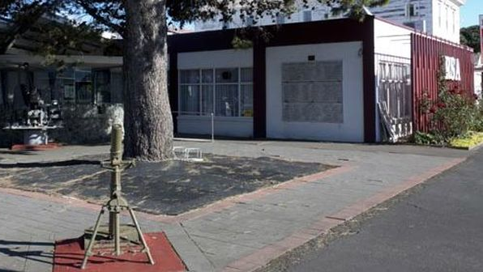

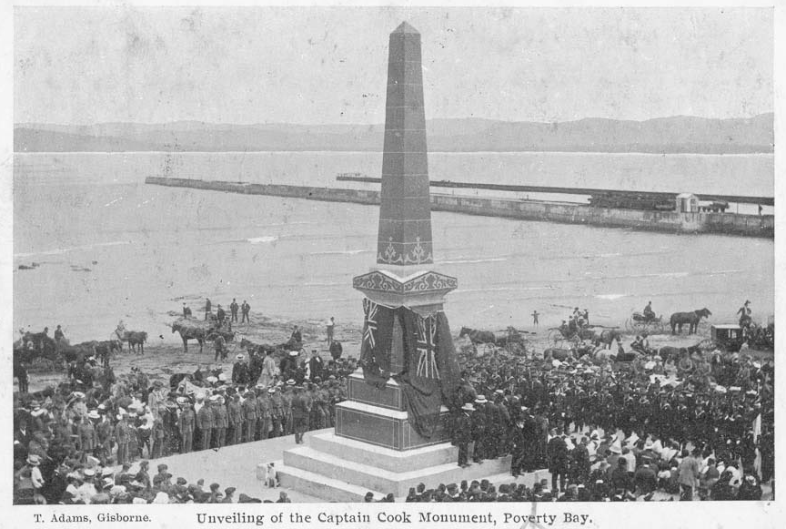
I have been told by “history experts” of today that this memorial has not been shifted, something that I find hard to believe as the beach is in easy reach of this memorial back in 1906. It was sited here so that it was always in site of the white cliffs of ‘Young-Nick’s Head’. Not so to-day. All you can see today when looking towards the sea is buildings and logs and there must have been an awful lot of land-fill done for those buildings to be on their present sites
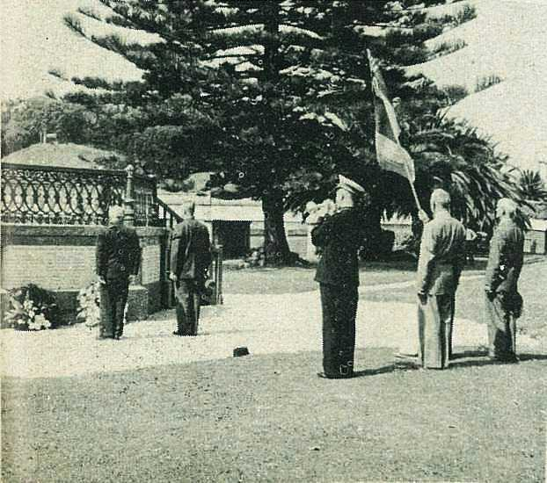

1957 - The ceremony is seen, as the Last Post was sounded.

Veldt Veterans Gather in Gisborne
"Old soldiers never die" would seem to be the impression given by more than two hundred veterans of the South African War who gathered in Gisborne last month for their annual conference. Although their average age was in the mid-seventies, they wore their years so lightly that when they formed up for parades the casual onlooker could be forgiven for mistaking them at least for men of the First World War. They came to Gisborne prepared to enjoy themselves, and they were given plenty of scope. The local South African War Veterans' Association, assisted by the Gisborne Returned Services Association and friends, turned on five days of hospitality which taxed even their undoubted powers of endurance. The weather was kind, and the whole conference was voted an outstanding success.

