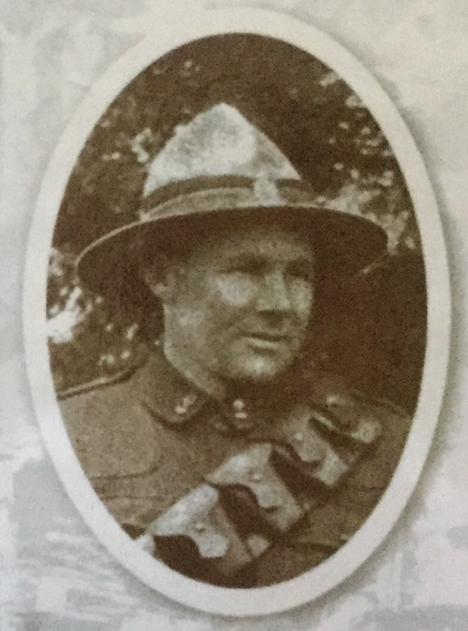
My Soldier’s Story

  - Lionel Edward Grimstone
  - By Tom Yalda

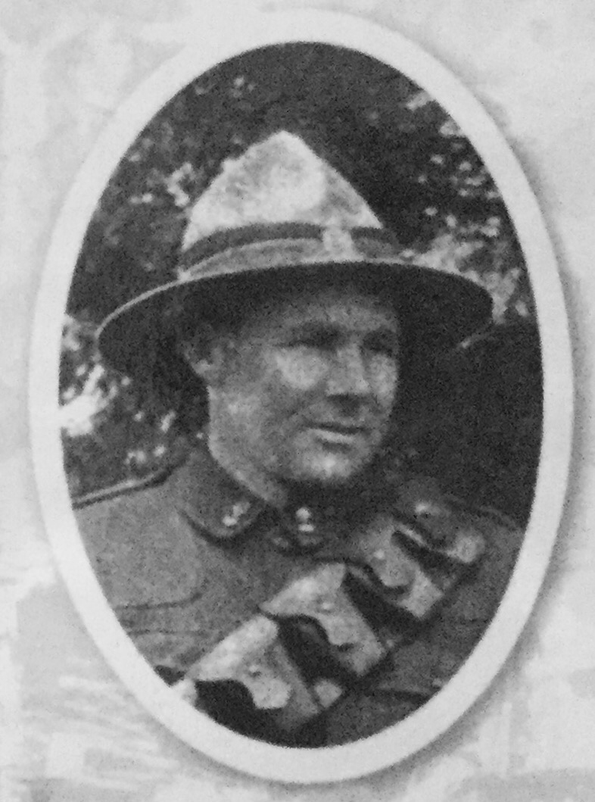
My Soldier’s Story

  - Lionel Edward Grimstone
  - By Tom Yalda

Contents:
Chapter 1 – Family/personal information
Chapter 2 – Education
Chapter 3 – Work after college
Chapter 4 – Enlistment in WW1
Chapter 5 – How Lionel died
Chapter 6 – Battle of his death
Chapter 7 – Cenotaph and medals achieved
Chapter 8 – Grave certificate and cemetery information
Bibliography
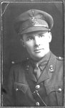
Serial number – 11/473 (Lieutenant)
Regiment – New Zealand Field Artillery

Chapter 1
Family/personal information

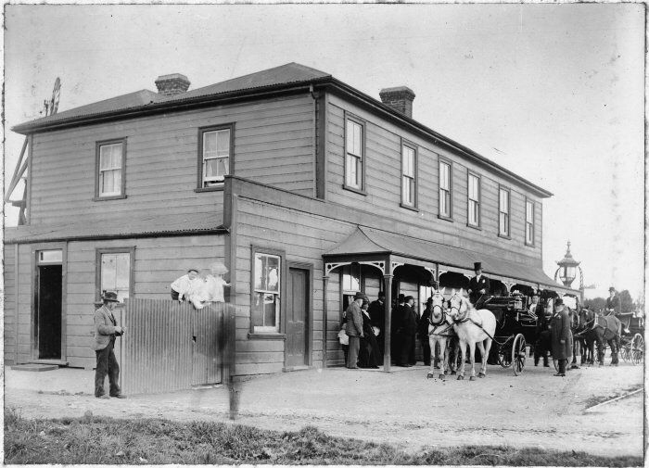
Lionel Grimstone was born in Alexandra the son of Leonard B. Grimstone and Alice M. Grimstone. His father had been the branch manager in the Bank of New Zealand (BNZ) in Alexandra since about 1893. Lionel had been one of two sons until his brother Reginald was tragically killed as a result of a landslide in a gravel pit when he was only 10 years old in 1905. Shortly after the accident the family moved to Paeroa where Leonard Grimstone was appointed manager of the BNZ. After a further move to Waitara the family finally settled in Ethlam. Lionel was 19 when he enlisted in the war and was among the first in Ethlam to sign up as well.

Chapter 2
Education

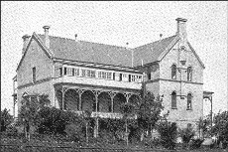
Lionel Grimstone attended Sacred Heart College for only two years but in those two years he made himself stand out in the crowd. Lionel was very popular at school and was very clever as well. He was known among his friends as ‘Grimmy’ as they thought Grimstone sounded a bit scary. Lionel, or Grimmy, was a member of the debating club for his skill at public speaking and clear and expressive speech. Lionel was also known for the same powers in the SHC production of Shakespeare. Lionel was also an official subscriber of the college magazine. Lionel was a very good boy at school because he was never naughty that's why all the teachers loved him as a student. The reason why Lionel was so good was because he cherished his education and followed his own motto, ‘the evil men do lives after them’. So he remembered that motto to never be a bad-behaved boy. Overall Lionel was a brilliant student and was remembered by his fellow peers.

Chapter 3
Work after College

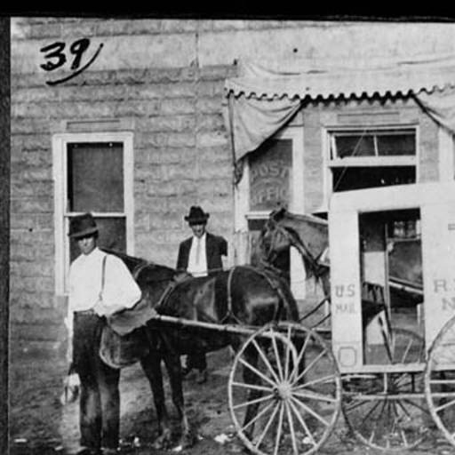
Lionel Grimstone worked as a Postmaster after he left college. A Postmaster is the head of an individual post office. When a postmaster is responsible for an entire mail distribution organisation (usually sponsored by a national government), the title of Postmaster General is commonly used. Responsibilities of a Postmaster usually include management of a centralised mail hand-out facility, confirming letter carrier routes, supervision of letter carriers and clerks, and enforcement of the organisation’s rules and procedures. In the days of horse-drawn carriages, a Postmaster was an individual from whom horses and/or riders (known as postilions or ‘post-boys’) could be hired. The Postmaster would stay in a ‘Post house’.

Chapter 4
Enlistment in WW1

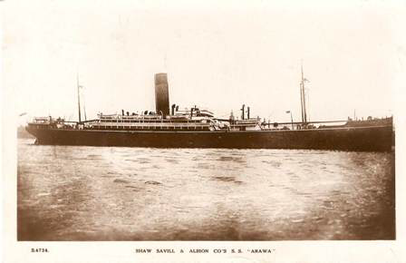
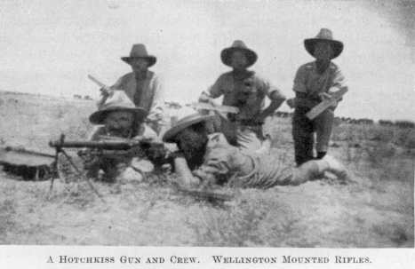
Lionel Grimstone enlisted in Canterbury, New Zealand. Throughout August, in preparation for the departure of the Main Body, columns of volunteers marched through their home towns en route to the four regional mobilisation camps. Each of New Zealand’s four military districts had one camp where NZEF units were being formed and equipped. Auckland recruits were sent to Alexandra Park, those from the Wellington region made the trip to Awapuni Racecourse in Palmerston North, Canterbury’s volunteers went first to Addington Park then Sockburn Park in Christchurch, and those from Otago military district camped at Tahuna Park in Dunedin. Before the troops departed for camps there were a series of farewells. There were personal farewells – where families said goodbye to their loved ones – as well as civic farewells in towns throughout the country. People lined the streets, waved flags and cheered on the troops as they set off. Family and friends gathered on railway station platforms for a last, anxious, farewell. He then left from Wellington on the Arawa (name of his vessel) on the 16th October 1914. The Arawa was carrying the Wellington Infantry Battalion (less West Coast Coy. and 7 and 8 Platoons), the Wellington Mounted Rifles Regiment. (less 2 troops), the Field Artillery Brigade (in part) and Signal Troop N.Z.E. After training in Egypt the WMR fought in the Gallipoli campaign from May to December 1915. On its return from Gallipoli the regiment spent another four months in Egypt before taking part in the Sinai campaign of 1916 and the Palestine campaign of 1917–18. After the armistice with the Ottoman Turks in October 1918 the WMR remained in Palestine until March 1919, when it was sent back to Egypt to help suppress nationalist riots. The regiment disbanded in June, when most of its officers and men embarked on the troop transport Ulimaroa for the return voyage to New Zealand.

Chapter 5
How Lionel Died

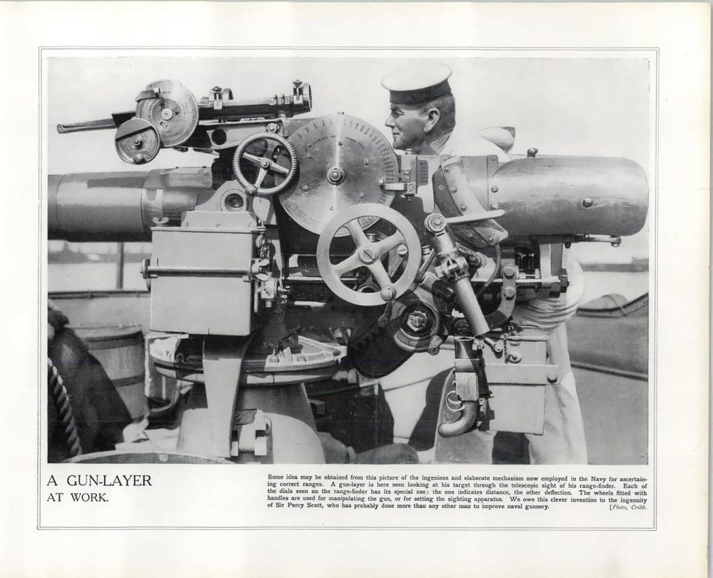
While serving in France as a gun layer (a person who goes out with a radar to track guns and finds enemy targets) Lionel went out with a team to search the perimeter for enemy targets. While searching he sent two of his team ahead, while they stayed back to search. When the two soldiers returned they said they had spotted 10 enemy targets and that they were heading in their direction. So Lionel said that they would ambush them, but that's where he went wrong. As the enemy approached the soldiers went silent, then BANG! One of Lionel’s men fell to the ground. “We’ve been seen!” said one of the men. Soon bullets were flying everywhere and one by one Lionel’s men died, until finally all but him was still remaining. He tried to call for reinforcements, but at that very moment, he was shot and sadly fell to the ground and slowly died in the sound of guns On 8 October 1918 in Le Cateau, France. May Lionel and his men be remembered. Confortare Esto Vir

Chapter 6
Battle of Lionel’s Death
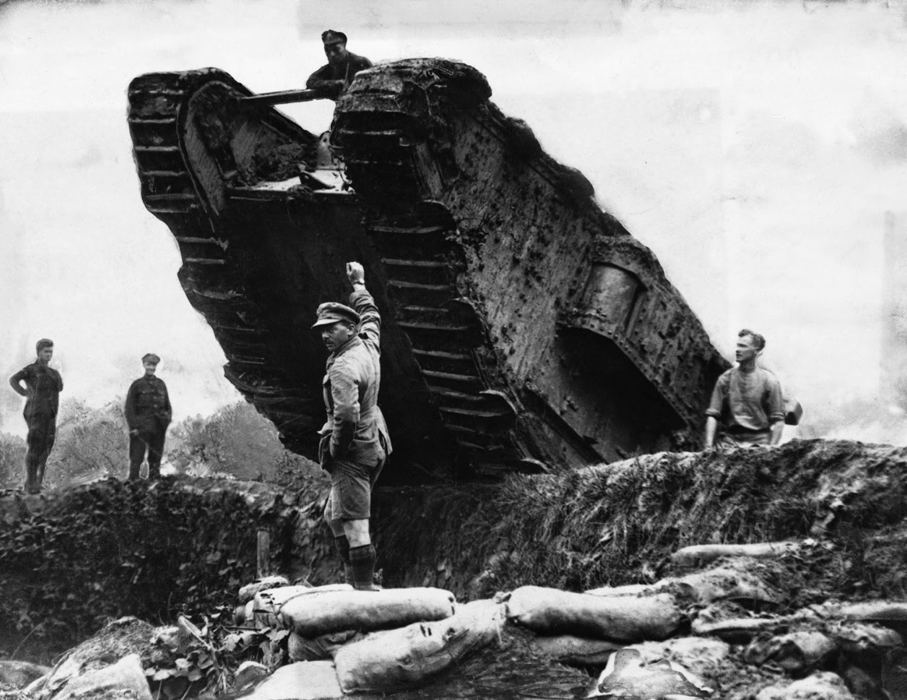
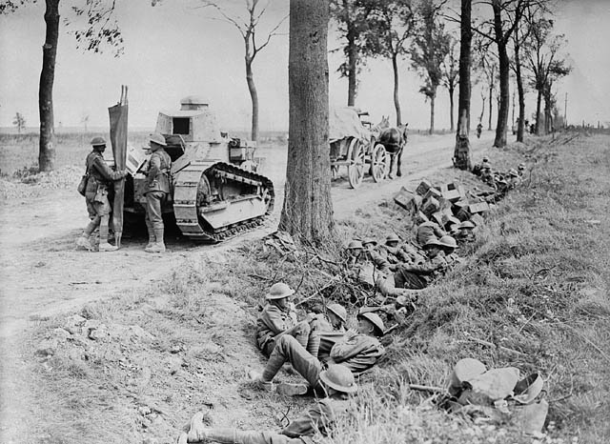
The Battle of Cambrai, 1918 (also known as the Second Battle of Cambrai) was a battle between troops of the British First, Third and Fourth Armies and German Empire forces during the Hundred Days Offensive of the First World War. The battle took place in and around the French city of Cambrai, between 8 and 10 October 1918. The battle incorporated many of the newer tactics of 1918, in particular tanks, meaning that the attack was an overwhelming success with light casualties in an extremely short amount of time.

Chapter 7
Cenotaph and medals achieved

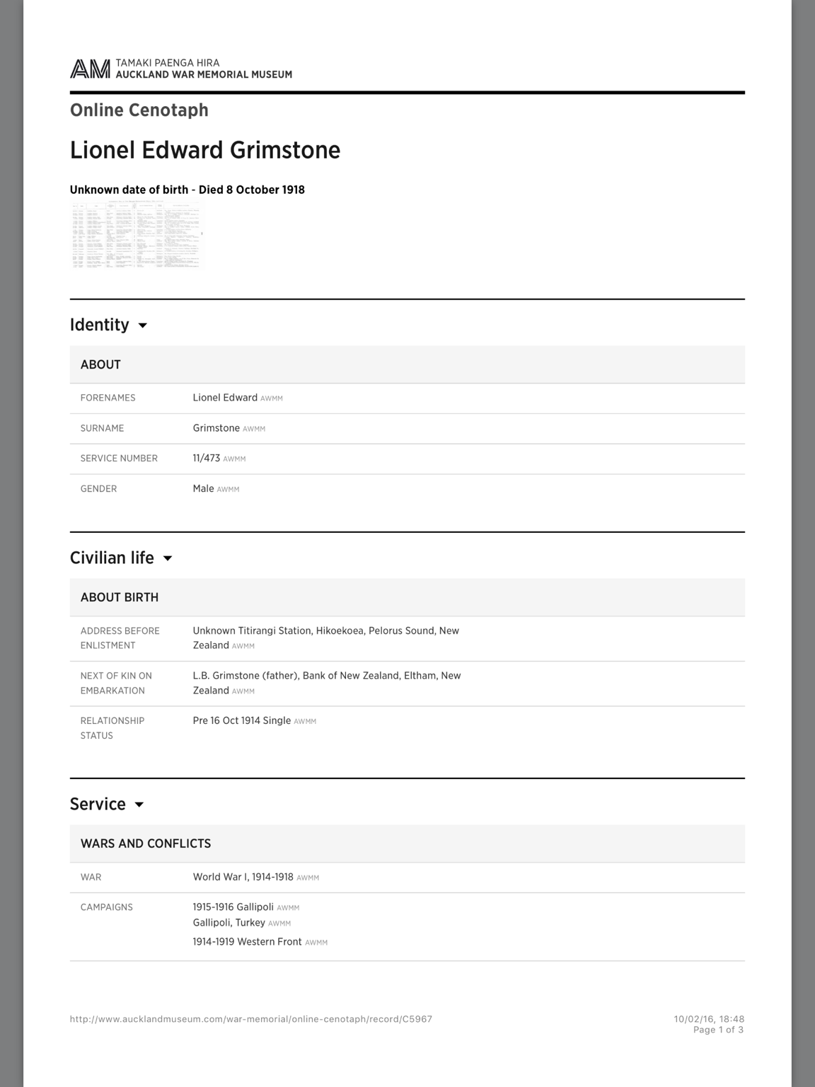
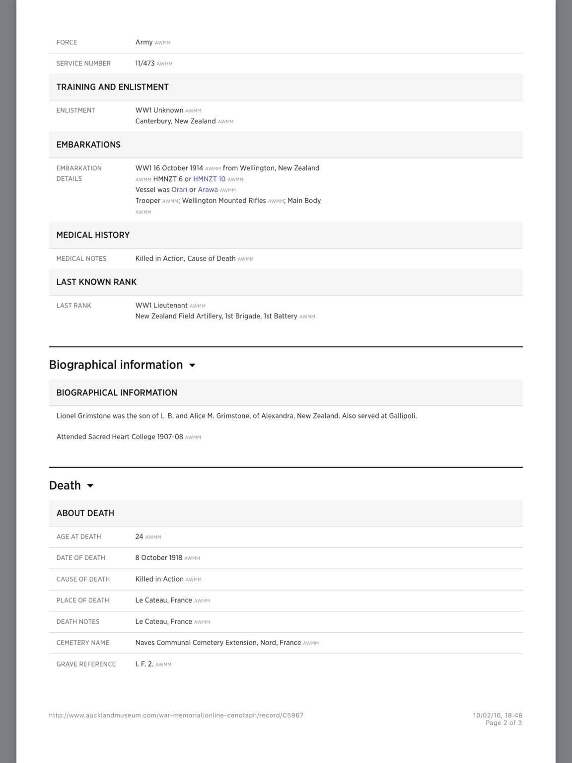
Lionel received two medals in the time he spent in the war. They are:
- The Anzac Commemorative Medal awarded for service in Gallipoli and in the Anzac campaign

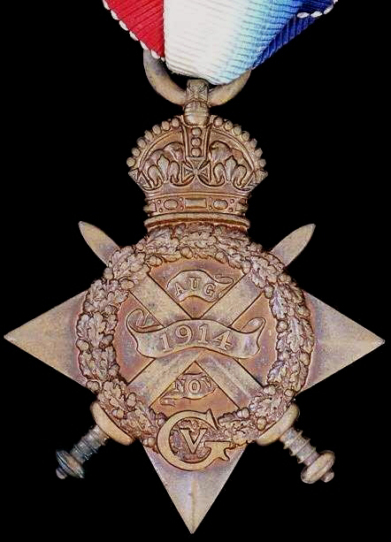
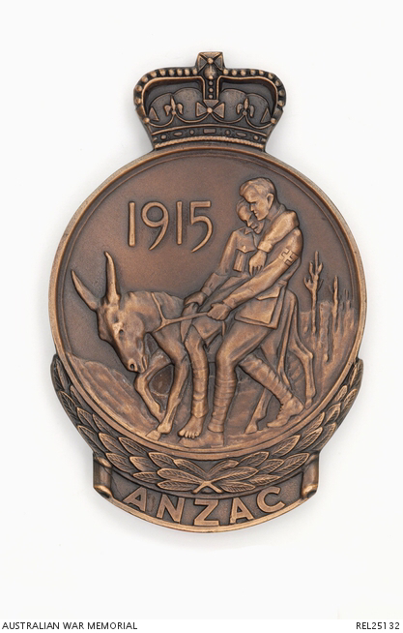
- The 1914 Star (also referred to ‘The Mon’s Star Medal’) Medal awarded for service in France in 1914
(Anzac Commemorate Medal). (1914 Star)

Chapter 8
Grave certificate and cemetery information

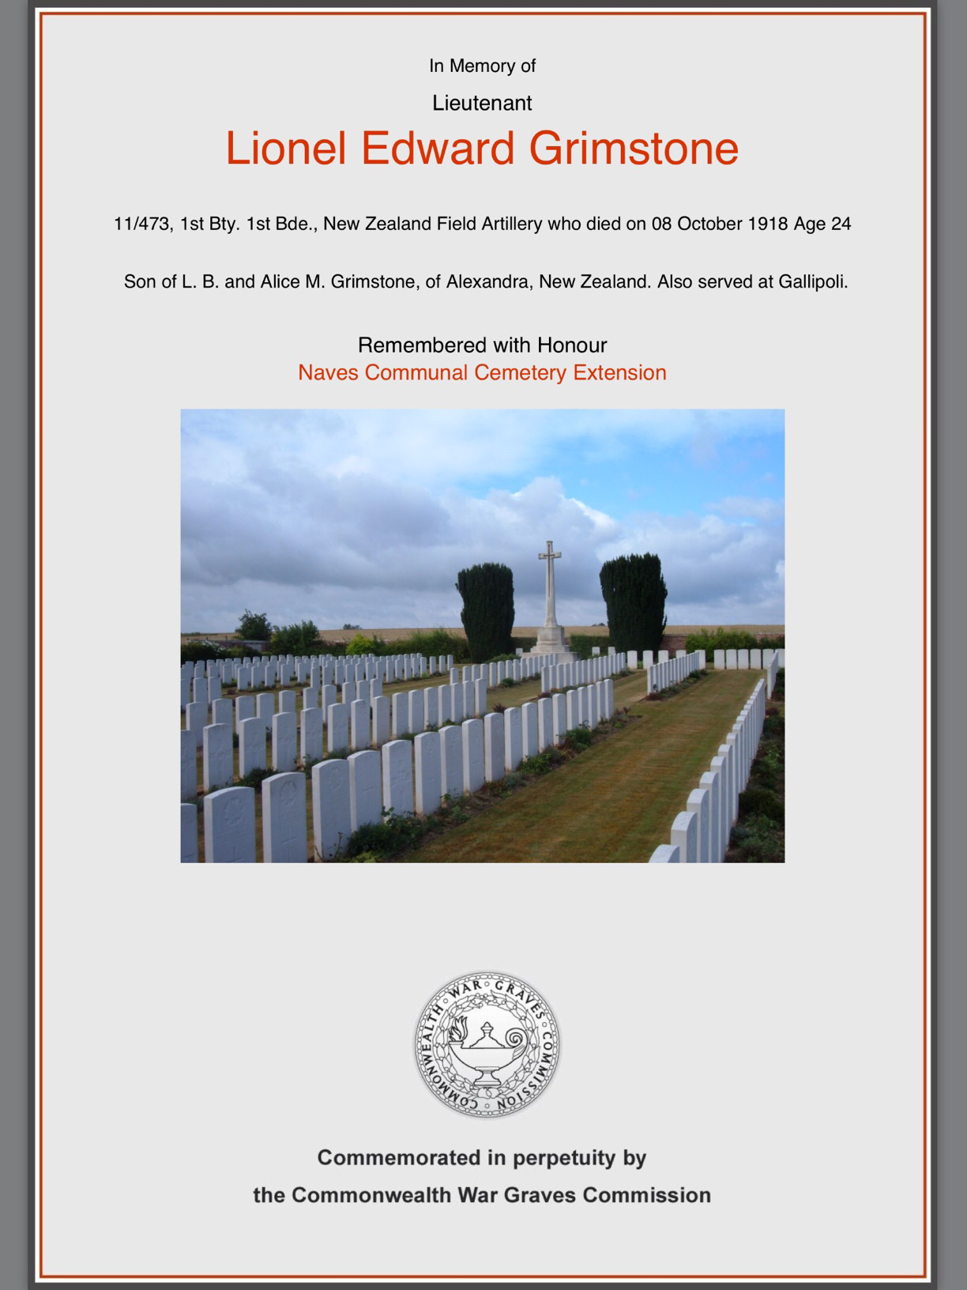
- Cemetery name: Naves Communal Cemetery Extension
- Country: France
- Locality: Nord

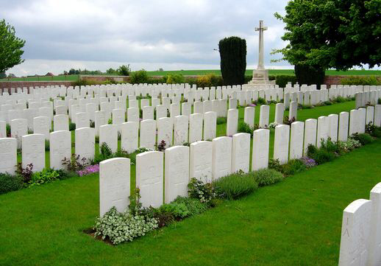
Historical Information: The cemetery was founded by the 49th West Riding Division in 1918.

